# Experiment No. 10

**AIM:**To deploy an Ecommerce PWA using SSL enabled static hosting solution.

**THEORY:**

The full form of PWA is Progressive Web Applications. PWA is HTML 5 webpage. It is a web application like a mobile application that is stored directly on the mobile from the website. In other words, it is a website that runs on the mobile browser of the user. PWA is a new technology. PWA allows the website to be stored in your device. It creates an icon in the form of a website app, and that icon feels like a mobile application upon opening.

After the PWA icon of the website is created in the device, all the posts that are open with the help of the internet, are automatically stored in your device which does not need the internet to read the second time. It is a methodology where we combine native app experience with the Browser feature.

Generally, when you have to build applications, you have to develop that application for different platforms, such as IOS, Android, and Windows.But in the case of PWA, you do not need to develop separate applications for different platforms. You only need to create HTML5 based webpages that can run on any mobile browser.

**Characteristics of PWA**

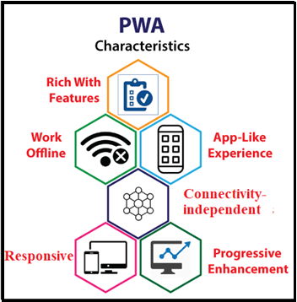

Progressive web applications have the following characteristics that are important to understand: Java

1. **Progressive:** The term progressive means, a PWA application must work on any device and improve the performance of the user's mobile browser and design.
2. **Discoverable:** A PWA is a website with some extra features. It can be searched via mobile searching applications like Google Chrome. App Store or Play Store is not required for this.
3. **Responsive:** The UI of a progressive web app should fit the form factor and screen size of the device.
4. **App-like:** A PWA application should look like a native application. Although the methods for creating, sharing, launching, and updating of the PWA are completely different from the original application.
5. **Connectivity-independent:** It works even when connectivity is very low.

How to convert the website into PWA using WordPress?

There are seven simple steps to convert a website to PWA.

The first thing to do is to log in to the WordPress admin of your website.

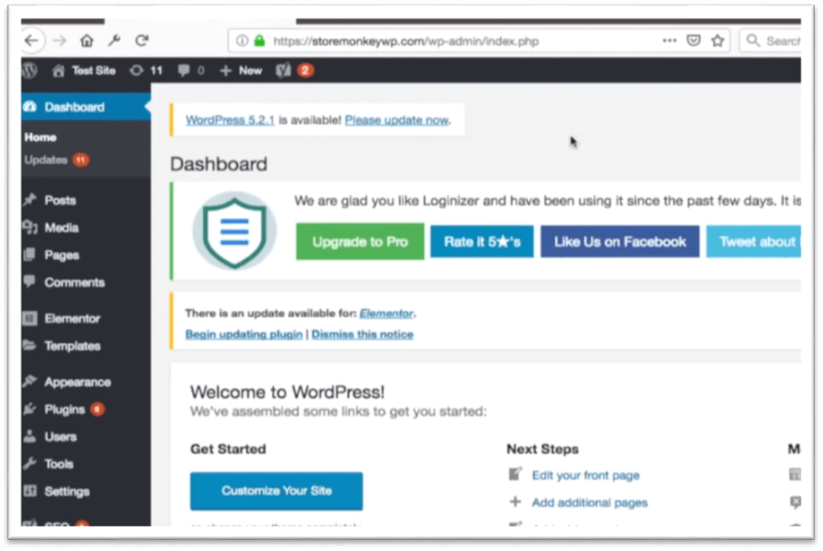

**Step 2**: After that, you have to go to the plugin option and click on the add new option.



**Step 3:** After this, click on the search button and search the plugin of the progressive web app and install it in WordPress.

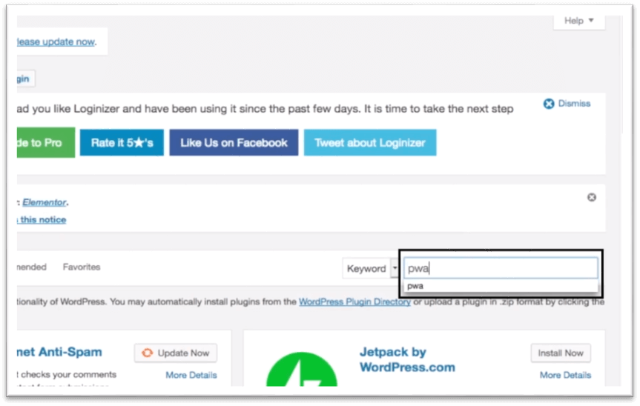

**Step 5:** Then, activate the plugin of the progressive web app.

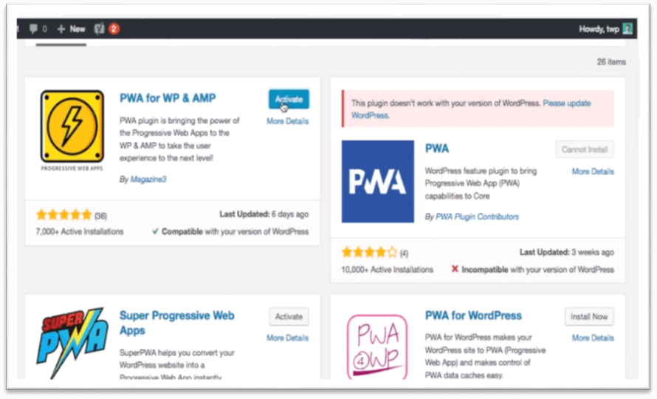

**Step 6:** Now, you will see many options in your dashboard (such as Application Name, Description, Icon, Color), which can customize as per your choice.

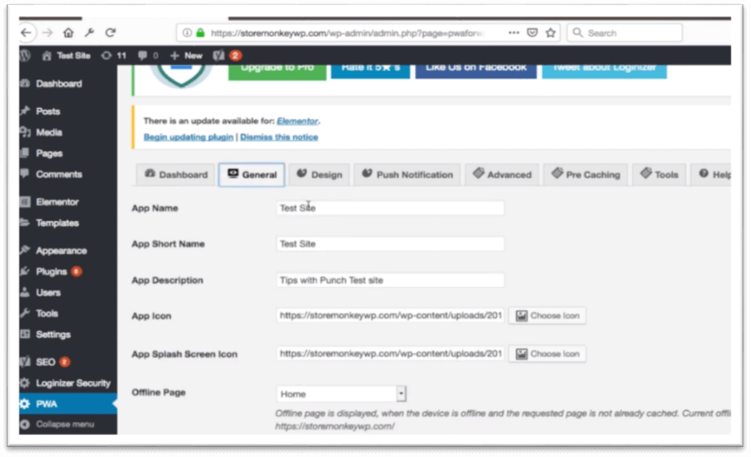

**Step 7:** Then click on the Save Settings button.

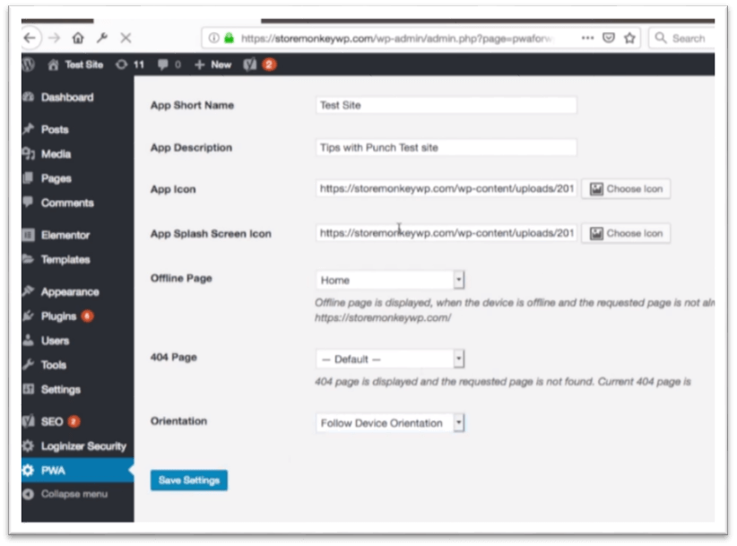

How do you install a PWA?

On Android phones, installing a PWA is pretty simple.

**Step 1:** The first thing to do is open google chrome on your mobile phone.

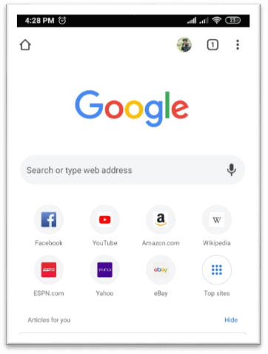

**Step 2:** Then, open the website, for example, Instagram.com.

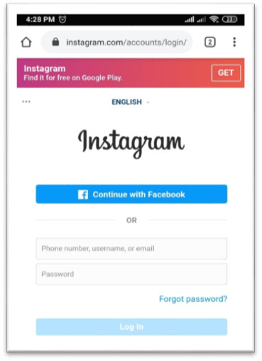

**Step 3:** Now, click on the three dots of the right corner in the google chrome.

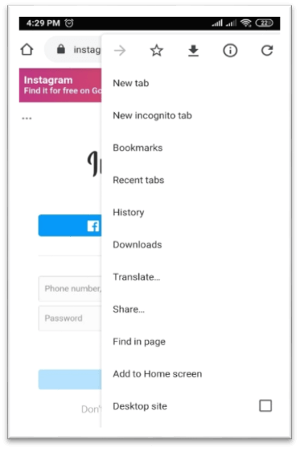

**Step 4:** Then, click on the Add to Home screen option and add it.

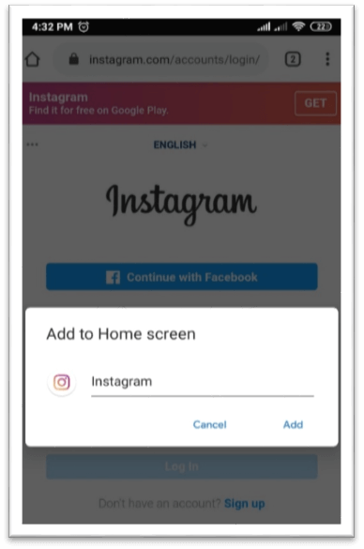

On iOS, you visit the website with the Safari browser and click the share icon. This opens a sub-menu with more icons and an option to save to the home screen.

**CONCLUSION:** Hence, we studied to deploy an Ecommerce PWA using SSL enabled static hosting solution.